Plymouth Rock Management Company of New Jersey
Palisades Safety & Insurance Association
Palisades Insurance Company
Palisades Property & Casualty Insurance Company
High Point Safety and Insurance Company
High Point Preferred Insurance Company
High Point Property and Casualty Insurance Company
Teachers Auto Insurance Company of New Jersey
Twin Lights Insurance Company
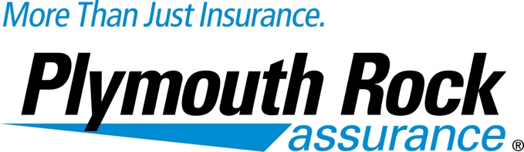

Eliminate Payment Delays

Have the money deposited and available faster

Plymouth Rock Assurance is making it easier for our preferred vendors/agents to receive payment through our ACH Deposit Program. By filling out this form you authorize Plymouth Rock Assurance to make all payments via electronic funds transfer directly into your designated account.

Enroll now!

Vendor Name___________________________________ Account #_________________

Vendor Address_______________________________________________________________

___________________________________________________________________________

Contact Name_________________________ Phone Number__________________________

Bank Name___________________________ Account Type___________________________
(Checking/Savings)

Routing/Transit Number_____________________ Account Number_____________________

Please fax completed form to Plymouth Rock at 908-978-6136 or email to anhayes@plymouthrock.com

Attn: Accounts Payable

If you have any questions please call: Andrea Hayes 732-908-6538

